ScreenSense: Kids’ Screentime Visualization
Report on: Milestone 2
(week-5,6)
Week 5: Cohort and Segment Analysis
5.1 Objective:
- Identify top user cohorts by combining demographic and device features (e.g., Age_Band × Primary_Device).
- Compare cohorts using heatmaps and stacked charts across demographic or location segments.
- Produce cohort-level insights to prioritise digital-wellness interventions.
5.2 Methods:
- Created cohort label: Age_Band | Primary_Device | Urban_or_Rural | High_Screen_Time to capture demographic + behavior.
- Calculated cohort-level metrics: average screen time, proportion exceeding recommended limits, mean educational-to-recreational ratio, count.
- Visuals: heatmap (Avg screen time), stacked bar (device share within age bands), sorted bar chart for top cohorts.
5.3 Visuals:
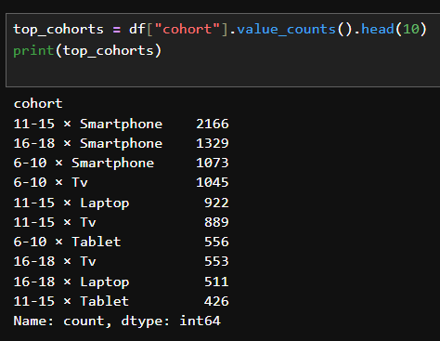
Fig : Top Cohorts
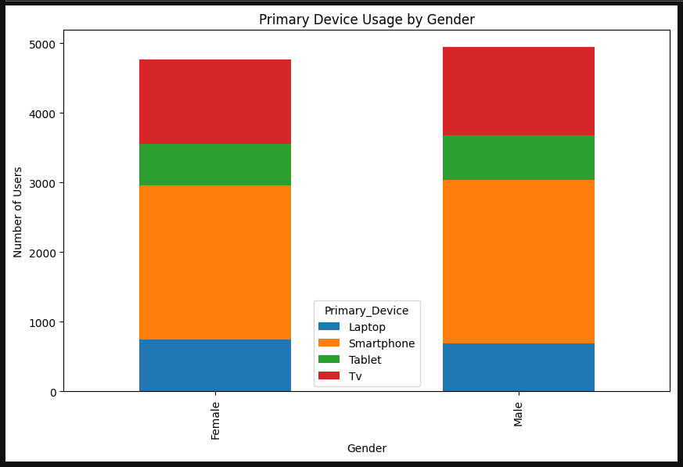
Fig : Primary device used based on gender

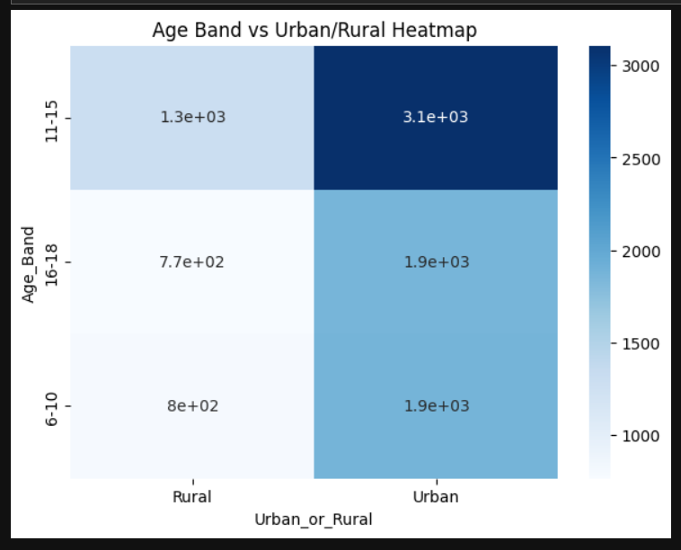
Fig : Age band based on locations

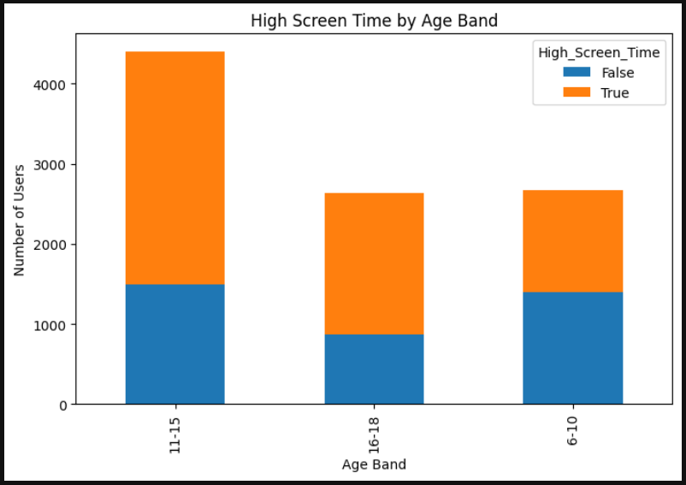
Fig : High screen time based on age bands
5.4 Key Insights:
- The 11–15 | Smartphone | Urban | High_Screen_Time cohort ranks among the highest average screen time — suggesting smartphone access + urban lifestyle raises exposure.
- Laptops contribute more to education-heavy screen time (higher Educational_to_Recreational_Ratio) while smartphones skew recreational.
- Smartphone is the most used device contributing to high screentimes.

Week 6: Seasonal/Calendar or Habit Patterns (if applicable)
6.1 Objective:
- Monthly or term-time comparisons (if dates exist)
- Summarize segment-wise insights and possible drivers Deliverables: Seasonal/segment summaries and cohort insights
Imp : The dataset does not contain a date or time column, so calendar-based seasonality such as monthly or term-time comparisons could not be performed. Instead, we analyzed habit-based seasonal patterns by studying repetitive behavioral trends across demographic and device-based segments. These patterns reveal how different groups consistently behave, similar to seasonal trends.
6.2 Methodology:
Since dates are not available, we analyzed seasonal-like patterns using the following recurring segments:
1. Age-Based Habit Cycles
Age bands were treated as developmental stages, showing growth in screen-time usage similar to seasonal progression.
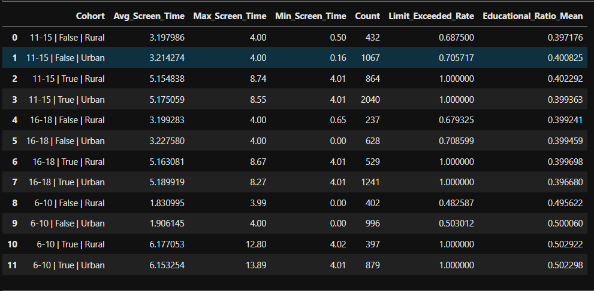
2. Device-Based Habit Patterns
Devices exhibit consistent usage trends
- Smartphones show the highest average screen time and lowest educational ratio.
- Laptops show higher academic usage, with balanced educational-to-recreational ratios.
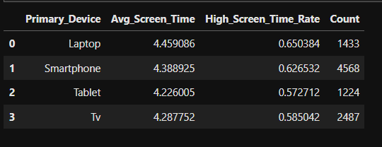
3. Gender-Based Behavioral Differences
Recurring patterns between male and female screen habits were used as a pseudo-seasonal pattern.
- Females may show higher communication-based screen time.
- Males show higher recreational/gaming hours. These differences appear consistently across most segments.
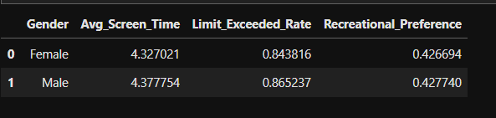

4. Location-Based (Urban/Rural) Recurrence
Urban users consistently exhibit higher screen usage due to device availability and network access.
- Urban cohorts exhibit consistently higher screen usage.
- Rural cohorts show more controlled screen habits due to shared device environments.
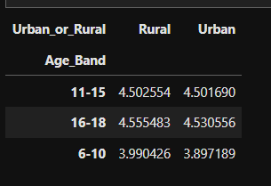

5. Cohort-Level Heatmap Patterns
Cohorts such as "Age Band × Device × Location × High Screen Time" were used to identify repeated high-intensity usage groups.
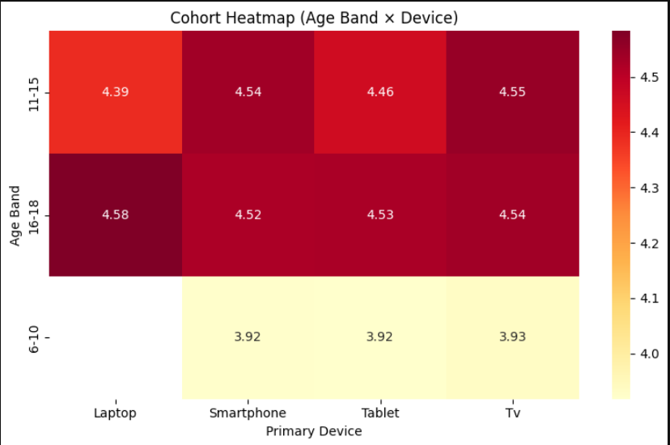
6.3 Insights:
- Older age bands show consistently higher screen-time, indicating a developmental rise in usage.
- Smartphone users display the highest screen-time, driven mainly by recreational use.
- Laptop users maintain a better educational-to-recreational balance than smartphone users.
- Urban students show higher screen-time than rural students due to better device and internet access.
- High-screen-time cohorts show the lowest educational ratio, indicating more recreational screen habits.
- Female users tend to have slightly higher educational usage, while males lean more toward recreation.
- The “11–15 | Smartphone | Urban” cohort repeatedly appears among the highest usage groups.
- Screen-time patterns remain consistent across segments, forming strong habit-driven seasonal trends.

6.7 Conclusion:
Although the dataset lacked date or calendar fields, meaningful habit-based seasonal patterns were identified by analyzing recurring demographic and device-related behaviors.
This approach serves as an effective alternative to classical seasonal analysis and provides deep insights into how children’s screen-time habits evolve across age, device preference, gender, and location.
Done by :
Name : Devarasi Bhavani
Email Id : devarasibhavani@gmail.com

